Clerkenwell & Shoreditch County Court,
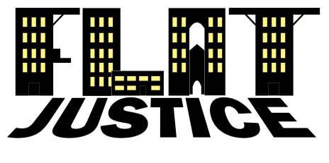
The Gee Street Courthouse
29-41 Gee Street
London
EC1V 3RE

Date*****

Dear Sir/Madam,

Please find attached our completed form N322b. Following guidance at EX328, p3, we understand that no fee is due (see below).
With kind regards
Yours faithfully,

Guy Morris
director

excerpt from ex328, p3:

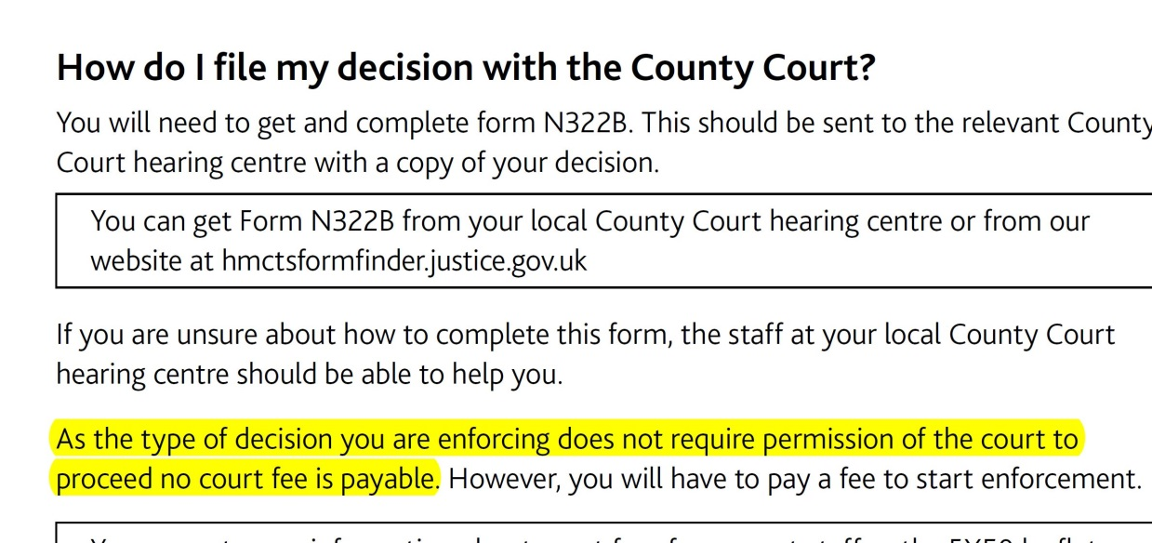

Flat Justice Community Interest Company Ltd Reg. No. 11502292

1st floor 85 Great Portland Street London W1W 7LT

07377748811 office@flatjustice.org www.GetRentBack.org

