The following link takes you to a resource used as a template by the Flat Justice team for their own casework. Please remove the FJ header & footer when used in a personal capacity. You can use the above “assisted by” logo instead if you want.
The template is in google doc format: to edit it choose ‘make a copy’:
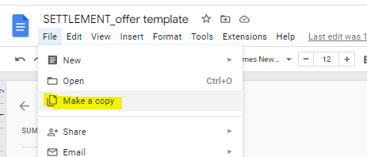

Then move it to whatever folder you need:
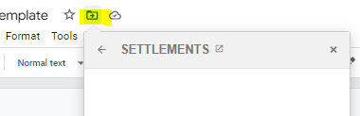

Statement of Case (SoC) template: copy the hyperlink below and paste it into a new browser url bar (for some reason clicking it doesn’t work!)

https://docs.google.com/document/d/1a0LI911Joj8lBJBPSI0cn9gQa-_Kqb-ne_2bg_S3IVw/edit?usp=sharing

